**MAINTENANCE PROGRAM INSTRUCTIONS**

**NOTE:** The following information is intended to provide a general overview of the maintenance program and how the maintenance documents should be used. Working under the direction of the body(ies) of elders, **the Operating Committee or maintenance coordinator is responsible for managing the maintenance program and updating the documents as outlined in these instructions.** (The Operating Committee or maintenance coordinator may utilize other qualified brothers and sisters to assist with organizing the work if needed.) Due to the variety of theocratic facilities and congregation circumstances in the branch territory, some of the information contained in the documents may not be applicable or may require editing to better suit local circumstances. Please strive to discern the intent of the documents and use them in a way that achieves the maintenance program’s goals—to extend the life of theocratic buildings, to make wise use of dedicated funds, and to involve a variety of local volunteers in the care and maintenance of their Kingdom Hall.

WHAT IS PREVENTIVE MAINTENANCE?

Preventive maintenance differs from the regular care or cleaning of the Kingdom Hall. While regular care items are very important, often times they focus on the cosmetic appearance or cleanliness of the building and property. Preventive maintenance tasks focus on scheduled inspections and repairs on equipment or building elements *before* they break down or deteriorate. This helps to ensure optimal working conditions and extends the life of the object being maintained. When preventive maintenance is not performed, reactive or emergency repairs become more frequent, which are typically performed under “less than ideal” circumstances. Good planning and use of the maintenance documents to organize the work result in a proactive approach that brings many benefits, including the savings of dedicated time and financial resources.

5 STEPS TO IMPLEMENT THE MAINTENANCE PROGRAM

* **STEP 1: DOWNLOAD THE MATERIAL AND PERFORM THE INITIAL EDITS.** Download all available “Maintenance Program” documents found under FORMS > KINGDOM HALL on [jw.org](http://jw.org). Once downloaded, these documents should be reviewed and edited as outlined in these instructions. Please contact the assigned maintenance trainer if assistance is needed.
* **STEP 2: DETERMINE THE APPROPRIATE SAFETY MEASURES.** Download *Working Together Safely* (DC-82) and *Congregation Job Hazard Analysis* (DC-85) from [jw.org](http://jw.org) under FORMS > SAFETY. Review the safety standards and identify all potential hazards associated with the property. Refer to the section ”The Importance of Safety” in this document for further details.
* **STEP 3: ORGANIZE THE MAINTENANCE DOCUMENTS.** Maintenance documents can be organized using a physical binder or an electronic folder structure. Refer to the section “Organizing the Maintenance Documents” in this document for further details.
* **STEP 4: ASSIGN THE VOLUNTEERS.** The maintenance program’s success will greatly depend on how well local volunteers are encouraged to participate. Refer to the sections “How to Use the *Yearly Maintenance Schedule* and *Task Instruction Cards*” and “How to Use the *Local Volunteer List*” in this document for further details.
* **STEP 5: CONDUCT INITIAL MAINTENANCE TRAINING VISIT. This initial visit will be conducted by the assigned maintenance trainer** to help the elders implement the maintenance program. It is hoped that the maintenance documents be completed and available for review at the time of the visit, with special emphasis given to completing the yearly schedule, task instruction cards, and *Congregation Job Hazard Analysis* forms. The maintenance trainer will also schedule and utilize skilled experts to provide hands-on training to those in the congregation(s) once the initial visit has been conducted.

11/16 Local Design/Construction 1

**MAINTENANCE PROGRAM INSTRUCTIONS**

HOW TO USE THE *YEARLY MAINTENANCE SCHEDULE* AND *TASK INSTRUCTION CARDS*

The *Yearly Maintenance Schedule* is an editable Microsoft *Word* document that organizes the maintenance tasks in harmony with the task instruction cards. Please determine which tasks should be included on the schedule and list them under the appropriate section. The schedule is divided into seven major sections: General, Building, Mechanical, Civil, Electrical, Equipment, and Technical. Volunteers should be assigned to the tasks and recorded on the schedule. The determined frequency to complete the task should be indicated on the schedule by highlighting the desired completion month(s) **(SEE EXAMPLE)** and match what is recorded on the corresponding *Task Instruction Card*.

The *Task Instruction Card* is an editable Microsoft *Word* document that provides basic instructions on how to complete a task, how often it should be performed, and a space to note additional repairs that may be needed. When the zipped folder containing the cards is first downloaded from [jw.org](http://jw.org), it will include all available task cards that have been developed by the branch office with generic instructions for each task. Please determine which tasks apply and delete cards in the zipped folder that are not applicable. If there is no card for a particular task, a new one may be created using the template found in the zipped folder. The task cards are meant to be edited as needed to reflect the actual inspection and/or preventive maintenance steps that should be followed. While the cards are beneficial, they are not intended to be the sole technical authority for the facility.

As tasks on the *Yearly Maintenance Schedule* are due for attention, the *Task Instruction Card* is given to the assigned volunteer along with any other additional information needed to complete the task, including the corresponding *Congregation Job Hazard Analysis* (DC-85) form. Each assigned volunteer is responsible for ensuring that the task is cared for in a timely manner according to the schedule. If the assigned volunteer is unable to complete the needed repair or requires assistance, other capable volunteers may assist.

* Special attention should be given to any item(s) in bold listed in the *Task Instruction Card*. These items correspond to what is stated in the *Facility Condition Survey* (DC-96) that is performed by the maintenance trainer on a biennial (once every two years) basis.
* If additional equipment or repairs are needed, the volunteer should notify the Operating Committee or maintenance coordinator prior to completing the work. This allows those in oversight to be aware of what is taking place and to approve additional costs associated with the repair.
* Please refer to the manufacturer’s documentation or consult other skilled experts if there is uncertainty on how to complete a task. Instructional videos and documentation found online can also be helpful.
* In some cases, local circumstances or codes require the use of licensed technicians. Or, the local elders may decide that it is better to have a task cared for by local contractors or service providers. In either case, the task should still be assigned to a volunteer and the appropriate arrangement for completing the work can be stated on the *Task Instruction Card*.

Once the task is complete, the *Task Instruction Card* should be updated by the assigned volunteer and reviewed by the Operating Committee or maintenance coordinator. Update the *Yearly Maintenance Schedule* by initialing the checked or highlighted box to indicate that the task is completed. **(SEE EXAMPLE)** Each year, a new yearly schedule and set of task cards should be created and made available for use. The yearly schedule and task cards from the previous year can be archived for reference.

11/16 Local Design/Construction 2

**MAINTENANCE PROGRAM INSTRUCTIONS**

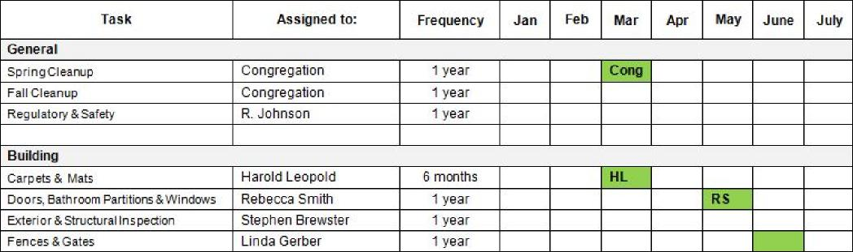

HOW TO USE THE *LOCAL VOLUNTEER LIST*

This editable Microsoft *Word* document is used to keep a separate record of volunteers and their skills within each congregation. By proactively recording the names of available volunteers and their skills, facility oversight can determine what resources are available locally when repairs are needed. It is important to comply with the age requirements listed in *Working Together Safely* (DC-82) when assigning volunteers from the list. While everyone should be involved in the routine care and cleaning of the Kingdom Hall, those assigned to maintenance tasks should be capable of completing the work as scheduled.

When assigning tasks on the yearly schedule, consult the *Local Volunteer List* and determine if there are any qualified volunteers that can be used – **both brothers and sisters can be used**. The goal is to equip local volunteers within the congregation(s) to care for as many tasks on the yearly schedule as possible. As hands-on training is provided, this can be documented on the list, with the aim of keeping an up-to-date record of all volunteers involved with the local program. **(SEE EXAMPLE)**

**CONGREGATION NAME:** North Chesterton

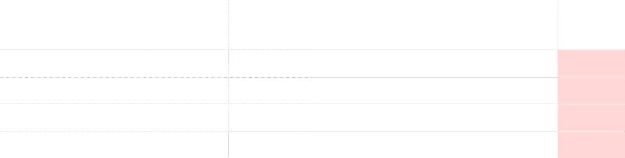

***Approved For High***

***Risk?***

***Name / Phone Number Skills***

Yes

Yes

Tom Greenlee, (845) 333-5555 Secular home builder, carpentry and HVAC specialty

Courtney Anderson, (845) 222-9999 Trained to do carpet cleaning; secular data entry

Andrew Hawkins, (845) 777-1111 Secular heavy equipment operator, roof installation Yes

Dianne Martin, (845) 555-4444 Trained to change light ballasts, service door hardware

11/16 Local Design/Construction 3

**MAINTENANCE PROGRAM INSTRUCTIONS**

THE IMPORTANCE OF SAFETY

Safe work practices are extremely important. Therefore, it is important to have a positive attitude toward safety with the goal of creating an accident-free environment when working at the Kingdom Hall. Volunteers and those in oversight of maintenance work should be familiar with the standards in *Working Together Safely* (DC-82). Before a member of the congregation can assist with maintenance tasks, they must read and sign the Statement of Commitment found on page 2 of their personal copy. In addition, before assignments are given for activities with a measure of risk, those overseeing the work will give clear safety reminders for each task on the *Yearly Maintenance Schedule*. Such reminders should be identified and documented in the *Congregation Job Hazard Analysis* (DC-85) form, which is used to identify potential hazards and the appropriate actions needed to prevent injury. This form should be made available with the corresponding task card.

In addition, it is good to review the *Spirituality and Safety* outline with volunteers when needed. This includes new volunteers that have not yet been exposed to the maintenance program or ones who would benefit from the reminders. If someone exhibits unsafe behavior and does not respond to loving reminders to apply safety standards, they should not be used to perform maintenance work. It is the responsibility of the local elders to stay current with the latest direction regarding safety at Kingdom Halls and to make application of such direction as soon as possible. This includes the use of *Working Together Safely* (DC-82), *Congregation Job Hazard Analysis* (DC-85) forms, *Incident Report Instructions* (TO-5i), *Incident Report* (TO-5) forms, and *Incident Report–Loss Evaluation* (TO-5a).

HOW TO USE THE *FACILITY OPERATIONS MANUAL*

This editable Microsoft *Word* document is used to provide basic information on the major building/property elements that have been identified. The systems are divided into categories that match the yearly schedule: Building, Mechanical, Civil, Electrical, Equipment, and Technical. Each entry should provide basic information about the equipment or system, including its components, location, date of installation, material type, manufacturer, model, serial number, specifications, how it operates, etc.

The list of systems and equipment has been prepopulated with common major systems and equipment found at many Kingdom Halls. Entries that do not apply may be removed and new entries can be added as needed. Volunteers assisting with Kingdom Hall maintenance should become familiar with the contents of the *Facility Operations Manual*. Having sufficient knowledge of how the building operates will help to prevent mistakes and promote safe work practices. **(SEE EXAMPLE)**

**MECHANICAL MAINTENANCE**

**ELEMENT / SYSTEM DESCRIPTION**



HVAC Three 5-ton Trane split units provide heating and cooling. The outdoor units are located on the north side of the hall. Each unit cares for a particular zone in the Hall (auditorium/foyer, library and second school/restrooms) The indoor units/air handlers include electric heat. These units are located in the mechanical room inside the hall. The distribution system includes metal trunk lines with flex duct to the registers. All equipment was installed in June of 2003. The system uses three 2” X 24” X 24” pleated filters.

Note: Please identify major building/property elements or systems and provide a brief description that details helpful information when repairs are needed. (Example: components, location, date of installation, material type, manufacturer, model or serial number, specifications, how it operates, etc.)

|  |  |
| --- | --- |
| Building Maintenance | |
| Element/System | Description |
| Structural Materials |  |
|  |  |
|  |  |

|  |  |
| --- | --- |
| Mechanical Maintenance | |
| Element/System | Description |
| HVAC |  |
| Plumbing |  |
|  |  |

|  |  |
| --- | --- |
| Civil Maintenance | |
| Element/System | Description |
| Waste Management |  |
|  |  |
|  |  |

|  |  |
| --- | --- |
| Electrical Maintenance | |
| Element/System | Description |
| Power Distribution |  |
|  |  |
|  |  |

|  |  |
| --- | --- |
| Equipment Maintenance | |
| Element/System | Description |
|  |  |
|  |  |
|  |  |

|  |  |
| --- | --- |
| Technical Maintenance | |
| Element/System | Description |
| Internet Service |  |
|  |  |
|  |  |

11/16 Local Design/Construction 4

**MAINTENANCE PROGRAM INSTRUCTIONS**

HOW TO USE THE *WORK HISTORY CARD*

This editable Microsoft *Word* document is used to keep a record of any upgrades, replacements, or other significant repairs performed at the facility. Only one card is needed to capture the work history for the entire location. As work is performed, update the card with the appropriate information. It can be referenced when determining the repair history of an element or component, how much was spent on the repair, who performed the work, etc. This will help facility oversight to monitor work activity and identify maintenance intensive items that may require alternative repair or replacement solutions. **(SEE EXAMPLE)**

HOW TO USE THE *SUPPLY LIST*



***Work History Description Date***

Replaced A/C compressor in Trane unit used for foyer, work done by local contractor, Cool-Time Systems, total cost was $643.00

Replaced the exterior light fixture above rear exit door, work done by D. Johnson, total cost of repair was $78.00

Repaired a bubble in carpet near entry off foyer, used glue to make the repair, work done by J. Holcomb, total cost was $22.00

5/1/2016

6/8/2016

7/12/2016

This editable Microsoft *Word* document is used to keep a record of frequently used items that are either regularly purchased or kept as supply inventory when performing maintenance at the Kingdom Hall. A walk-through of the building and property will help identify these items so they can be recorded. It is good to be specific with the supplier and item information. This will allow facility oversight to quickly locate the needed item and help prevent purchasing the wrong materials. If desired, additional information may be included such as supply cost, quantities to keep on hand, or other helpful details to ensure that sufficient supplies are available. **(SEE EXAMPLE)**

11/16 Local Design/Construction 5

HOW TO USE THE *RECOMMENDED CARE/CLEANING LIST*

This editable Microsoft *Word* document provides basic recommendations regarding the regular care and cleaning of the building and property. Facility oversight should determine the specific items that need to be included on the list. Some congregations may decide to edit the document to include field service group assignments, contact information of responsible brothers, and/or additional instructions for volunteers. Therefore, unlike other documents in the maintenance program, this list is not restricted and the format can be customized accordingly. Copies of the list can be placed on the information board or supply closet for the congregation(s) to readily access.



T-8 Light bulbs Phillips

Home Depot

#422949

Box of 10 bulbs

***Item Supplier/Manufacturer Model/Part/Serial Number***

Toilet Paper Stock-Now Janitorial TP-3998

Box of 12 rolls

Hand Soap Stock-Now Janitorial SP-1002 Refill Cartridges

Box of 4 refills

**MAINTENANCE PROGRAM INSTRUCTIONS**

ORGANIZING THE MAINTENANCE DOCUMENTS

It is important to organize the various documents related to the maintenance program and to keep them in a location that is accessible to the various ones assigned to maintenance tasks. Working under the direction of the body(ies) of elders, each Operating Committee or maintenance coordinator can determine whether a physical binder or an electronic folder structure will be used to organize the documents. As documents are compiled, please arrange them as outlined in the following chart:



**SECTION: DOCUMENT CONTENTS:**

***Information*** *Maintenance Program Instructions; Facility Operations Manual; Work History Card; Supply List*

***Safety*** *Working Together Safely* (DC-82); “Spirituality and Safety” talk outline; *Incident Report Instructions* (TO-5i); blank *Incident Report* (TO-5); *Congregation Job Hazard Analysis Instructions* (DC-85i); *Incident Report–Loss Evaluation* (TO-5a); applicable safety data sheets for products used at the Kingdom Hall



***Schedule/Volunteers*** *Yearly Maintenance Schedule*; *Recommended Care/Cleaning List*; *Local Volunteer List* (1 per congregation)

***1 – General*** All applicable *Task Instruction Cards* and *Cong. Job Hazard Analysis* (DC-85) forms

***2 – Building*** All applicable *Task Instruction Cards* and *Cong. Job Hazard Analysis* (DC-85) forms

_Pic52

***3 – Mechanical*** All applicable *Task Instruction Cards* and *Cong. Job Hazard Analysis* (DC-85) forms

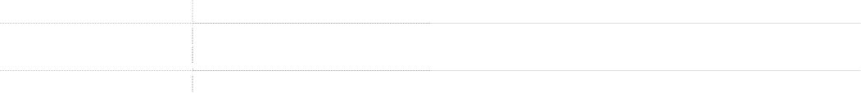

***4 – Civil*** All applicable *Task Instruction Cards* and *Cong. Job Hazard Analysis* (DC-85) forms

***5 – Electrical*** All applicable *Task Instruction Cards* and *Cong. Job Hazard Analysis* (DC-85) forms

***6 – Equipment*** All applicable *Task Instruction Cards* and *Cong. Job Hazard Analysis* (DC-85) forms

***7 – Technical*** All applicable *Task Instruction Cards* and *Cong. Job Hazard Analysis* (DC-85) forms

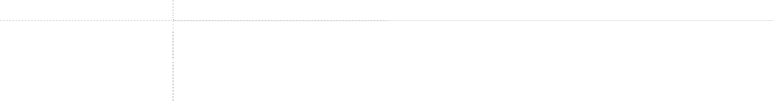

***Additional Documents*** All available and up-to-date as-built construction drawings (landscape, architectural, mechanical, electrical, and plumbing); service contracts; etc.

***References*** Helpful maintenance references found locally or supplied by the trainer; product manuals; etc.

Local congregation members should be encouraged to become familiar with using the various maintenance documents. In addition, they should feel free to report anything that needs attention or to offer suggestions that may improve how a maintenance task is cared for. Regular maintenance activity and training encourage all involved to become well acquainted with their Kingdom Hall and to have a positive view toward this aspect of sacred service.

11/16 Local Design/Construction 6

**MAINTENANCE PROGRAM INSTRUCTIONS**

FREQUENTLY ASKED QUESTIONS

**WHAT SHOULD BE PLACED UNDER THE “ADDITIONAL DOCUMENTS” TAB?**

This section has been provided to store documents that are pertinent to the facility. This may include copies of licenses, permits, registrations, service contracts, manufactures’ warranties, commissioning documentation, service manuals, wiring diagrams, or documents like these. If physical drawings are available, they should be stored in a safe location that can be easily accessed when needed.

**WHAT SHOULD BE PLACED UNDER THE “MAINTENANCE REFERENCES” TAB?**

This section has been provided to store any helpful information regarding the maintenance of the facility. This may include references that are found locally or items provided by the maintenance trainer. Such references encourage training and can be used to learn the proper way to care for various tasks.

**WHAT IS OUR RESPONSIBILITY TOWARDS SPECIAL FULL-TIME SERVANT (SFTS) HOUSING?**

The body(ies) of elders has a responsibility to maintain housing on the Kingdom Hall property. The maintenance of branch-owned housing that is used by an occupant attending the congregation or vacant branch-owned SFTS housing located in the same neighborhood or territory may be assigned to the elders as well. In either case, the Operating Committee or maintenance coordinator can determine the method of managing the maintenance tasks, taking into account the circumstances and abilities of each occupant.

The local brothers may decide that a separate yearly schedule is needed for the occupant to keep track of

the items they care for. It may also be decided to supply a limited number of task instructions to the occupant so that they are familiar with how to safely care for the task. However, for the sake of simplicity, the local brothers may also decide to incorporate the housing maintenance tasks into the schedule used for the Kingdom Hall with the understanding that the occupant will care for specific items.

**WHAT IF THERE ARE MULTIPLE LANGUAGES USING THE MAINTENANCE BINDER?**

Currently, the maintenance documents are only available in English and Spanish. When multiple language congregations use the Kingdom Hall, it will be left to the Operating Committee to determine whether the information should be made available in multiple languages, which will require good communication to ensure that all tasks are assigned and that the schedule is updated accordingly.

**WHAT IF THERE ARE MULTIPLE BUILDINGS ON THE PROPERTY?**

Generally, only one operating committee is formed to care for all buildings on the property. It is preferred that the number of documents be limited to what is needed to properly care for the building. If multiple schedules are used, good cooperation and communication will be needed to avoid overlap of shared maintenance tasks between the various buildings.

**WHAT IS THE ROLE OF THE MAINTENANCE TRAINER?**

The maintenance trainer is assigned by the Local Design/Construction Department (LDC) to assist you with implementing the maintenance program. Although he is not responsible for the maintenance activity at your Kingdom Hall, he has been assigned to help arrange maintenance training for the local volunteers. He is also responsible for conducting biennial (once every two years) assessments of all theocratic buildings assigned to him and submits requests related to the property that require LDC approval. Typically, he will communicate with the Operating Committee chairman or maintenance coordinator when making arrangements related to your Kingdom Hall. The maintenance trainer also has an assistant to help with the many tasks involved with this assignment. If married, both the maintenance trainer and his assistant may include their wives in the assignment when appropriate.

11/16 Local Design/Construction 7